Docker Task -2

Task Description:

Create a dockerfile, docker-compose file which when executed must display your basic details in the website.

Volume – Backup storage:

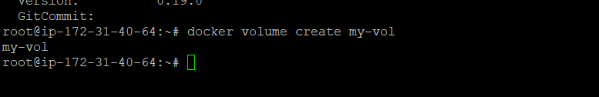
To know which path my volume is located:
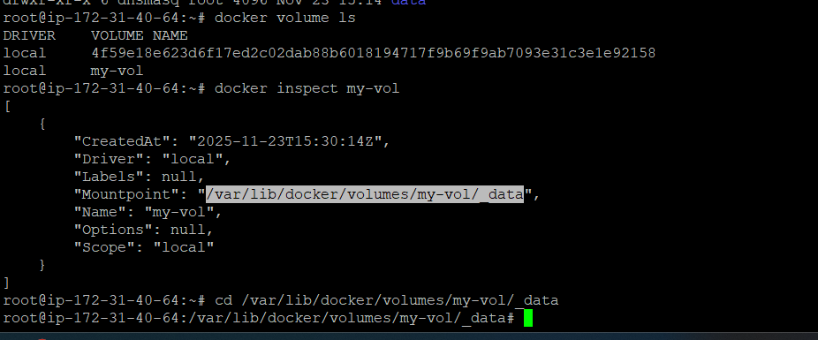
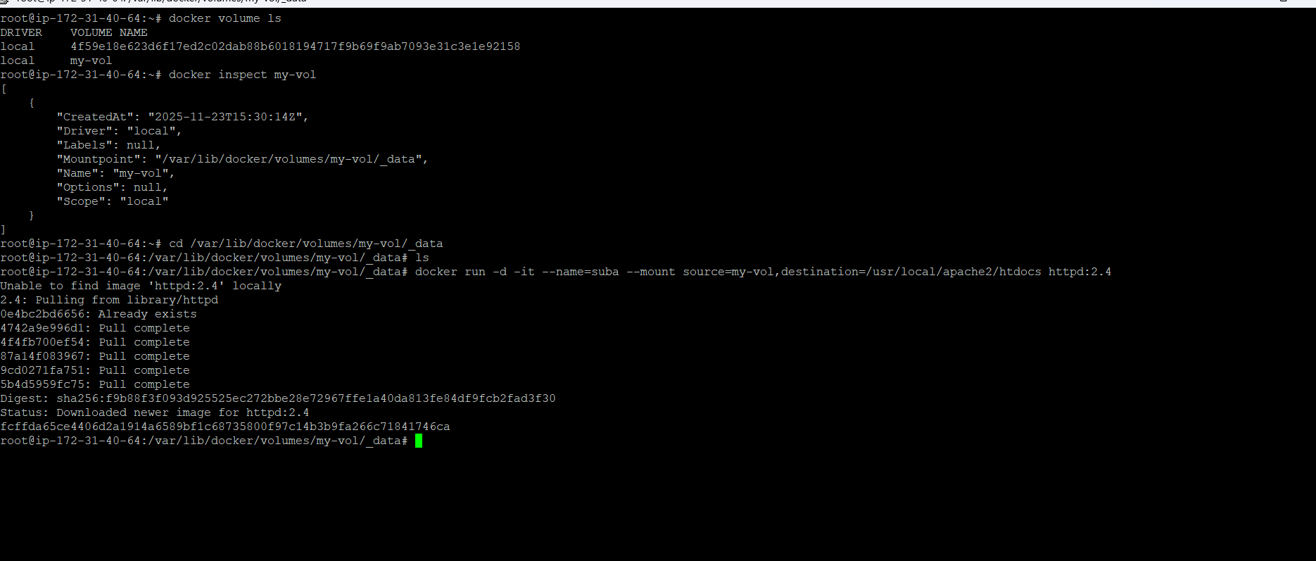
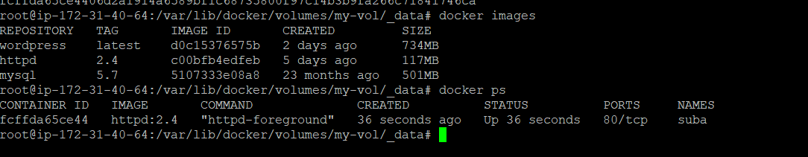
Index.html file inside the path. Whatever present n the path which I given in the container that is also automatically sync.
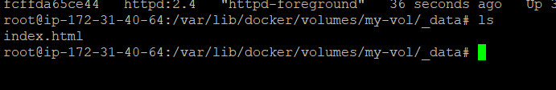
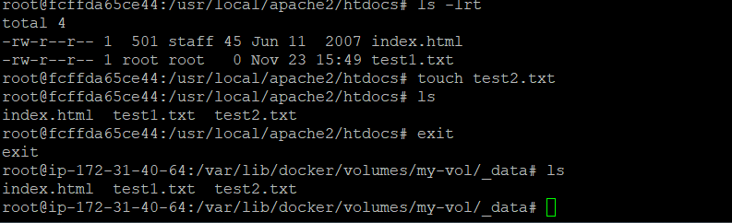
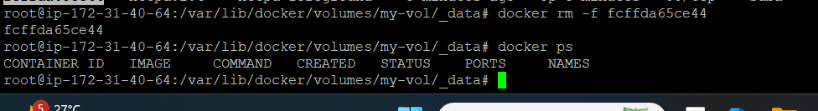
Eventhough container deleted, the data is available in myvol:

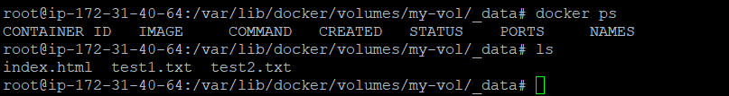

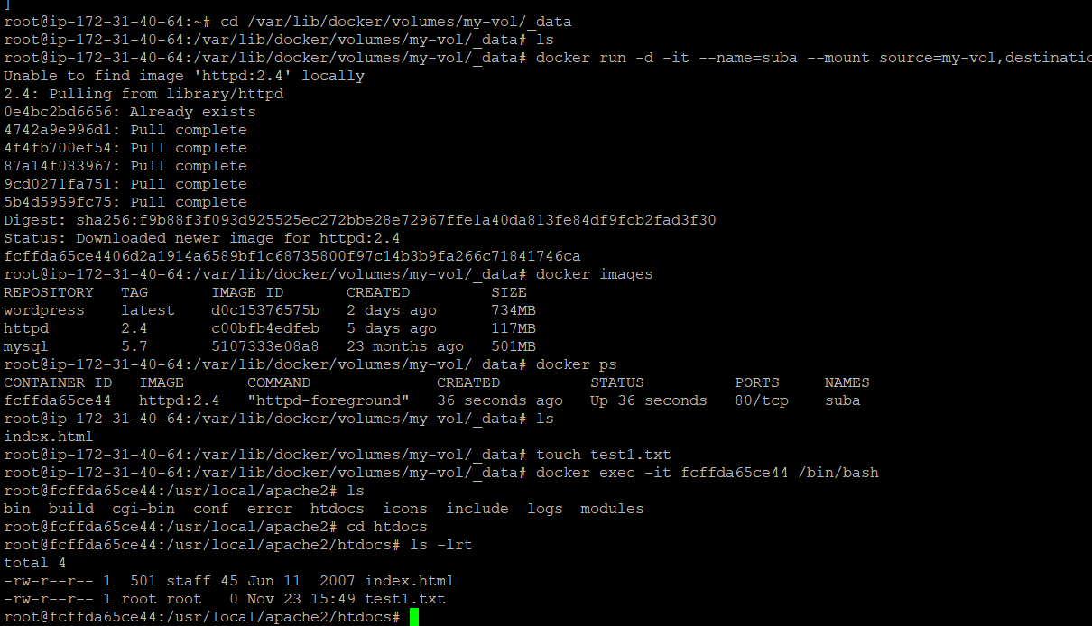
Tried viceversa:
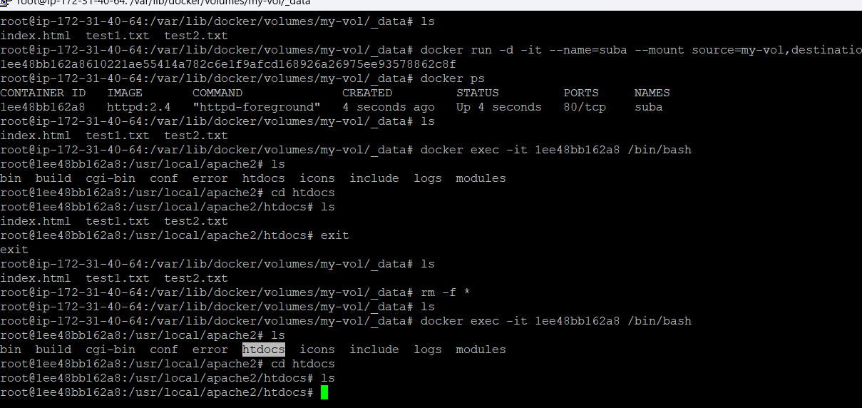

Docker network :
Default 3 networks:
1.bridge, host none.
Container created without any nw specifications, docker will run default container with bridge.

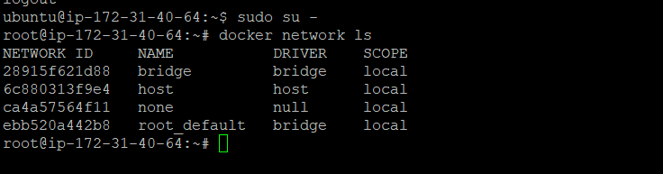

I have created two containers with alpaine public images.
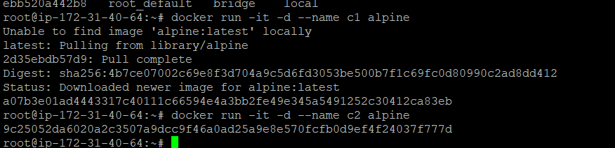
These 2 container have separate nw address
Ip address: C1: IPAddress": "172.17.0.4"
Ip address : C2: "IPAddress": "172.17.0.3",
By default, both containers are created by using common network bridge.
Inside c1 container, tried to connect c2 by using ip address, it is reply by pinging.but when I tried to connect by name c2. It shows bad address.
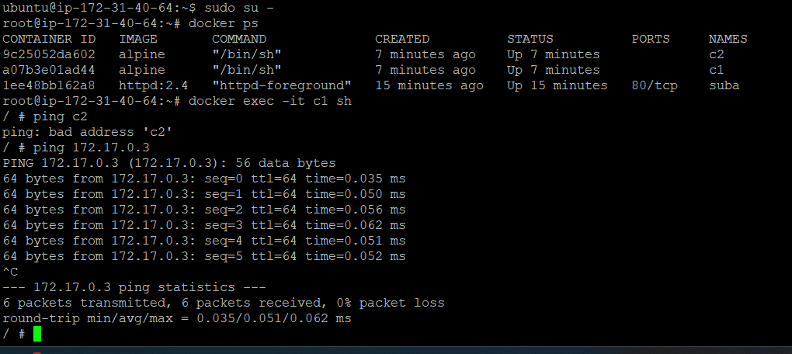

In this case, need to create customised network:
I use common drive, will create a common network:
Private network create:
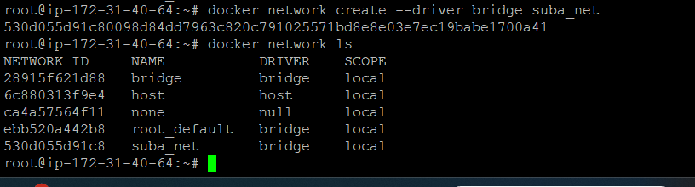

I have created two container on my network:
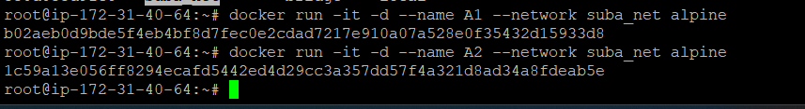
I go inside the A1 container, trt to ping A2 by using the name not ipaddress.

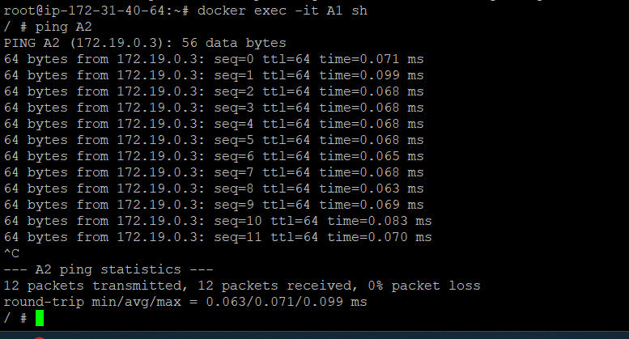
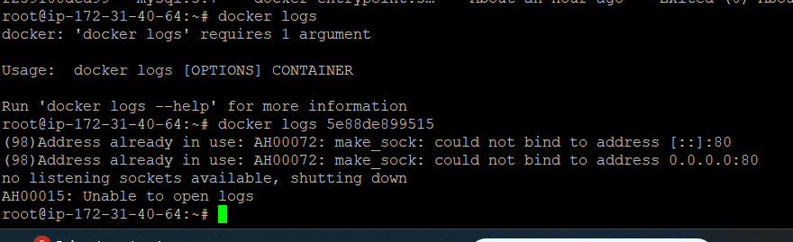

All the stopped containers removed:
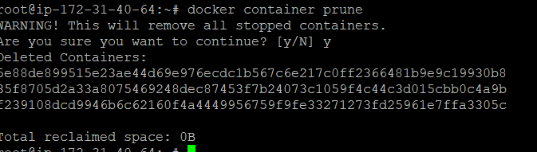

Docker file:
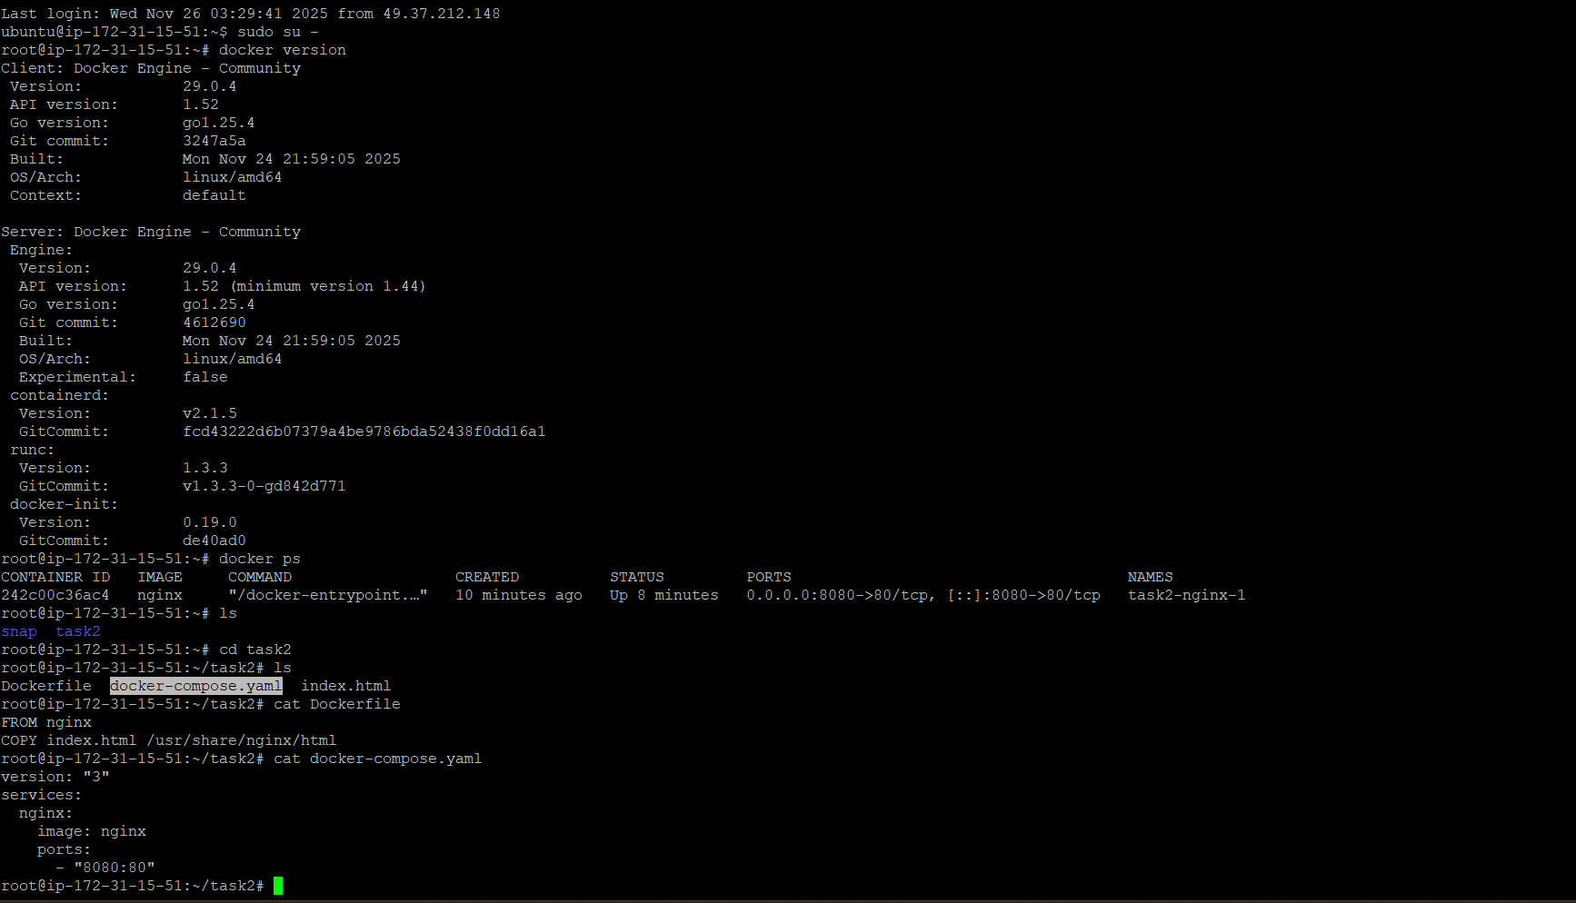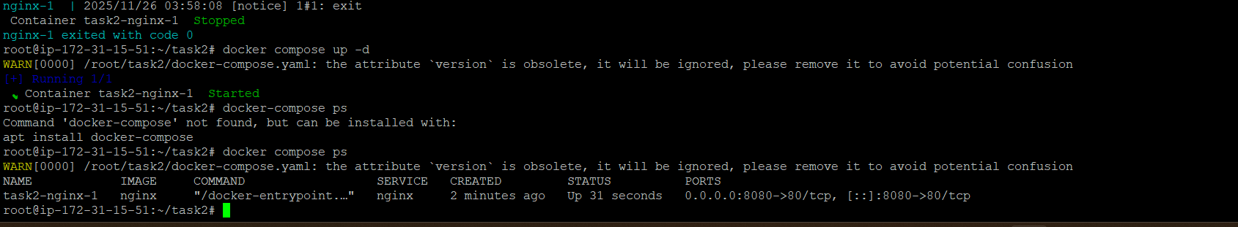

Need to edit inbound rules:
